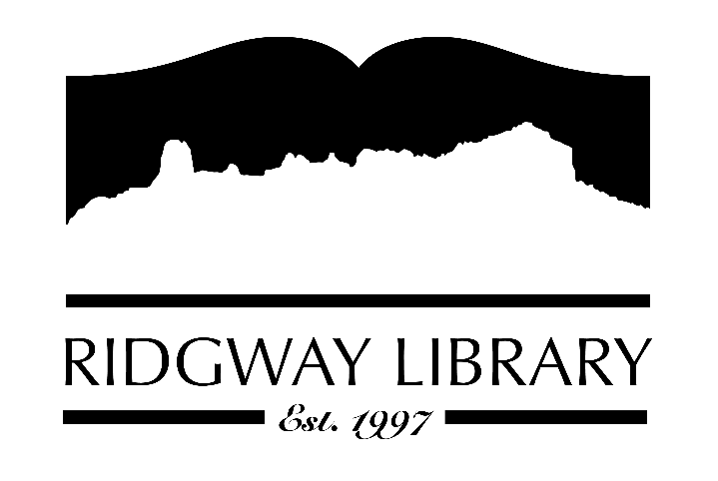

AGENDA
RIDGWAY PUBLIC LIBRARY DISTRICT
BOARD OF TRUSTEES
Regular Meeting
Thursday, April 16, 2026 at 10:00 a.m.

Ridgway Public Library
300 Charles Street

Roll Call: Trustees: Julie Duff, Alison Etheridge, Jared Coburn, Julie Herrmann, Dee Moore, Heather Patterson, Sally Trapp, Library Director: Amy Baer

Approval of Prior Minutes: from March 12, 2026 meeting

Next Meeting: Thursday, May 14, 2026 at 10:30 a.m.

Public Comments: Upcoming Garden Composting Class on Saturday, April 25th at 10:00

Friends of the Library Update: Next meeting is Tuesday April 21st at 3:50 to discuss the Annual Fun Fest to be held on Saturday, May 30th. Volunteer opportunities will be available.

Highlighted Topic:

Action and Discussion Items:
- Treasurer’s Report – Julie Duff
- Director’s Report – Amy Baer
- Strategic plan work session with CliC consultant – all trustees

Treasurers Report - Julie Duff
- Budget update (see above)

Director’s Report - Amy Baer
- Statistics (share monthly & 2025 Annual Report
- CDE Grant Update
- Betsy to attend YA workshop in Denver Saturday, April 18th
- Outdoor spring maintenance to begin

Future Agenda Items

Sally to discuss CAL president’s zoom forum outcomes and goals

Adjournment
The Board reserves the right to add or delete items of business and to change the order of business as needed. The Board welcomes public participation in the meetings. If specific accommodations are needed, please contact the Director, Amy Baer, (970)626-5252 or email abaer@ridgwaycolibrary.org at least 24 hours in advance of the meeting.

