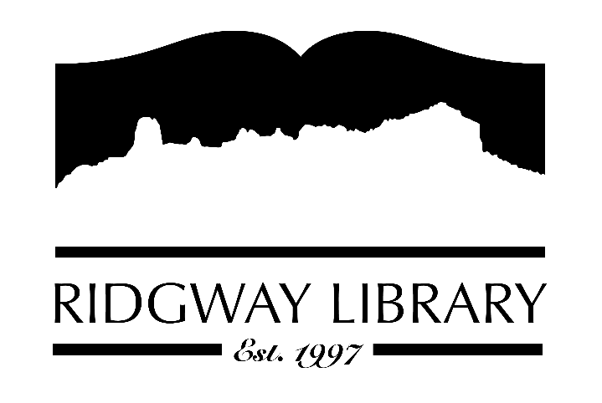

AGENDA
RIDGWAY PUBLIC LIBRARY DISTRICT
BOARD OF TRUSTEES
Regular Meeting
Friday March 14, 2025 at 10:30 a.m.

Ridgway Public Library
300 Charles Street

Zoom option:
https://us06web.zoom.us/j/87843609274?pwd=tVt5HcTxgn64zzm4aGETk0ISndn4bU.1

Passcode:
523053

Roll Call: Trustees: Julie Duff, Alison Etheridge, Jared Coburn, Julie Herrmann, Dee Moore, Heather Patterson, Sally Trapp, Library Director: Amy Baer

Approval of Prior Minutes: from February 13, 2025 meeting

Next Meeting: proposed meetings for 2025 (April 10th, June 12th, Sept 11th, Oct 9th, Nov 13th, Dec 11th) at 10:30 a.m.

Public Comments:

Friends of the Library Update:

Highlighted Topic: Upcoming Garden Class on Saturday March 15th at 10:00

Action and Discussion Items:
- CAL Award updates – Dee
- Roof Update - Sally
- Follow up on attorney notes – Sally
- Review Material Selection Policy - Sally
- Review Goals - Sally
- Create additional sub committees as needed

Treasurers Report - Julie Duff
- Budget update

Director’s Report - Amy Baer
- Statistics & Programs
- Maintenance Updates
- Staff Youth Conference

Future Agenda Items

Adjournment
The Board reserves the right to add or delete items of business and to change the order of business as needed. The Board welcomes public participation in the meetings. If specific accommodations are needed, please contact the Director, Amy Baer, (970)626-5252 or email abaer@ridgwaycolibrary.org at least 24 hours in advance of the meeting.

