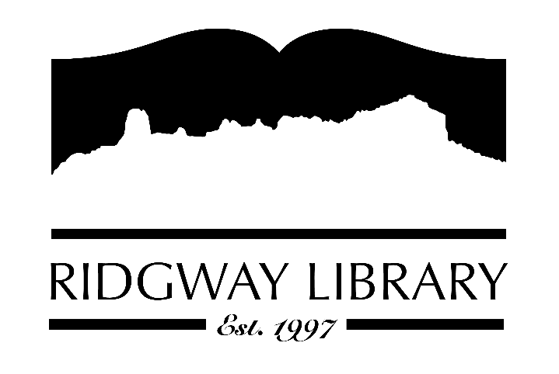

AGENDA
RIDGWAY PUBLIC LIBRARY DISTRICT
BOARD OF TRUSTEES
Regular Meeting
Thursday, December 11, 2025 at 10:30 a.m.

Ridgway Public Library
300 Charles Street

Zoom option:
https://us06web.zoom.us/j/86315126340?pwd=66ymltsdrjASiC7b38FhMh7kR5xvJV.1

Passcode:
322679

Roll Call: Trustees: Julie Duff, Alison Etheridge, Jared Coburn, Julie Herrmann, Dee Moore, Heather Patterson, Sally Trapp, Library Director: Amy Baer

Approval of Prior Minutes: from November 13, 2025 meeting

Next Meeting: Thursday, January 8, 2026 at 10:30 a.m.

Public Comments:

Friends of the Library Update:

Highlighted Topic: Lunchtime Book Club on Thursday December 18th at 12:00 and Sewing Class to start making mug rugs at 1:00

Action and Discussion Items:
- Sign off on Budget for the Ridgway Public Library – Julie Duff & Amy Baer
- Update on tote bag and possible approval - Heather
- Discussion & possible action regarding strategic plan process - board

Treasurers Report - Julie Duff
- Budget update

Director’s Report - Amy Baer
- Wrap up of 2025 and upcoming 2026 programs

Future Agenda Items
- Elect officers for 2026

Adjournment
The Board reserves the right to add or delete items of business and to change the order of business as needed. The Board welcomes public participation in the meetings. If specific accommodations are needed, please contact the Director, Amy Baer, (970)626-5252 or email abaer@ridgwaycolibrary.org at least 24 hours in advance of the meeting.

