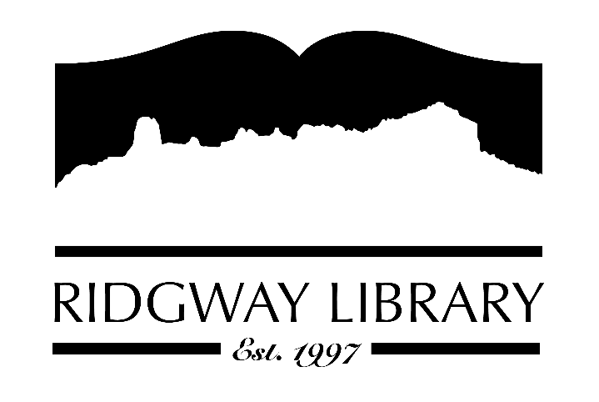

AGENDA
RIDGWAY PUBLIC LIBRARY DISTRICT
BOARD OF TRUSTEES
Regular Meeting
Thursday, May 28, 2026 at 9:00 a.m.

Ridgway Public Library
300 Charles Street

Zoom option:
https://us06web.zoom.us/j/83562432981?pwd=17Ty8uIQPNW2JV0M6nUTtRt55Pes8n.1
Passcode:
023759

Roll Call: Trustees: Julie Duff, Alison Etheridge, Jared Coburn, Julie Herrmann, Dee Moore, Heather Patterson, Sally Trapp, Library Director: Amy Baer

Approval of Prior Minutes: from April 16, 2026 meeting

Next Meeting: June meeting TBD

Public Comments:
.
Friends of the Library Update: Family Fun Fest on May 30th from 10:00-1:00. FORL shirts have been received.

Highlighted Topic: Summer Reading Challenges to begin on June 1st & Summer programs to begin on Thursday, June 4th

Action and Discussion Items:
- Strategic Plan Meeting with CliC consultant – all trustees

Treasurers Report - Julie Duff
- Budget update

Director’s Report - Amy Baer
- Statistics

Future Agenda Items

Sally to discuss CAL president’s zoom forum outcomes and goals

Adjournment
The Board reserves the right to add or delete items of business and to change the order of business as needed. The Board welcomes public participation in the meetings. If specific accommodations are needed, please contact the Director, Amy Baer, (970)626-5252 or email abaer@ridgwaycolibrary.org at least 24 hours in advance of the meeting.

