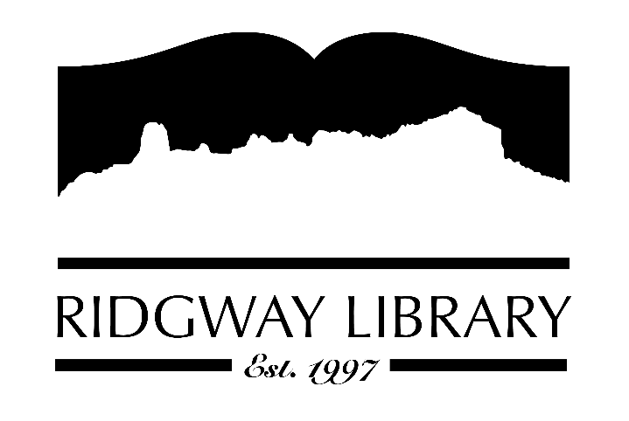

AGENDA
RIDGWAY PUBLIC LIBRARY DISTRICT
BOARD OF TRUSTEES
Regular Meeting
Thursday, February 12, 2026 at 10:30 a.m.

Ridgway Public Library
300 Charles Street

Zoom option:
https://us06web.zoom.us/j/83578125125?pwd=AcPbvBFPcZ8kwIB0wjOSFFvat6PagB.1

Passcode:
626914

Roll Call: Trustees: Julie Duff, Alison Etheridge, Jared Coburn, Julie Herrmann, Dee Moore, Heather Patterson, Sally Trapp, Library Director: Amy Baer

Approval of Prior Minutes: from January 8, 2026 meeting

Next Meeting: Thursday, March 12th at 8:30 a.m. w/ CliC Consultant

Public Comments:

Friends of the Library Update: Tote Bags available for purchase at the library front desk for $10 donation.

Highlighted Topic: Friday, February 13, 2026 at 4pm Terra Malmstrom presents Beyond Survival: Kenotic Love & Honeybee Wisdom

Action and Discussion Items:
- Sign off on 2025 Audit Exemption – Amy
- Strategic plan update & discussion – trustees
- Announce CAL conference Sept. 9-11 in Aurora (registration opens May 26th)

Treasurers Report - Julie Duff
- Budget update

Director’s Report - Amy Baer
- Programming Updates
- Library Computer Updates
- CDE Grant Update
- PLAR Update
- CliC Workshop

Future Agenda Items

Adjournment
The Board reserves the right to add or delete items of business and to change the order of business as needed. The Board welcomes public participation in the meetings. If specific accommodations are needed, please contact the Director, Amy Baer, (970)626-5252 or email abaer@ridgwaycolibrary.org at least 24 hours in advance of the meeting.

