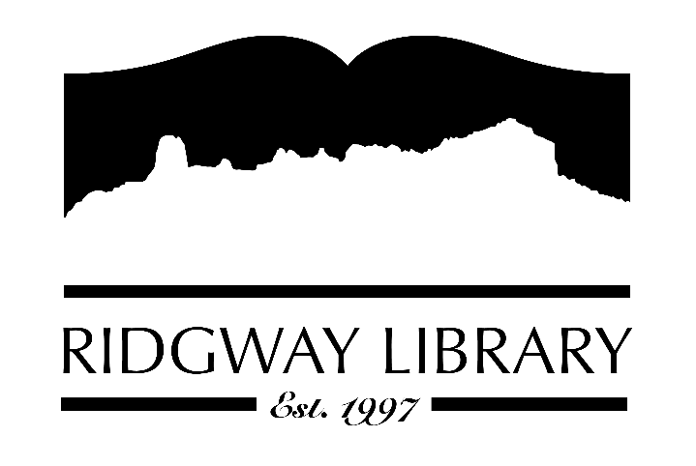

AGENDA
RIDGWAY PUBLIC LIBRARY DISTRICT
BOARD OF TRUSTEES
Regular Meeting
Thursday, January 8, 2026 at 10:30 a.m.

Ridgway Public Library
300 Charles Street

Zoom option:
https://us06web.zoom.us/j/81313548601?pwd=U8WEiEf4fB1jY1T7Dq7yzAm5tSb9BK.1
Passcode:
096802

Roll Call: Trustees: Julie Duff, Alison Etheridge, Jared Coburn, Julie Herrmann, Dee Moore, Heather Patterson, Sally Trapp, Library Director: Amy Baer

Approval of Prior Minutes: from December 11, 2025 meeting

Next Meeting: set schedule for 2026

Public Comments:

Friends of the Library Update:

Highlighted Topic: Adult Bingo began on January 2nd and will run through March 31st

Action and Discussion Items:
- Notice of Annual Meeting of the Board and designate the public place of postings for all notices as the library bulletin board.
- Elect officers for 2026 – all trustees
- Submit officers and terms to BOCC
- Strategic plan update – Sally

Treasurers Report - Julie Duff
- Budget update

Director’s Report - Amy Baer
- Statistics
- Library Updates

Future Agenda Items

Adjournment
The Board reserves the right to add or delete items of business and to change the order of business as needed. The Board welcomes public participation in the meetings. If specific accommodations are needed, please contact the Director, Amy Baer, (970)626-5252 or email abaer@ridgwaycolibrary.org at least 24 hours in advance of the meeting.

